**R.Kousalya( 19001189 ) PostMan Assignment Day 5**

**Postman??**

Postman is an API platform for building and using APIs. Postman simplifies each step of the API lifecycle and streamlines collaboration so you can create better APIs—faster.

**Why PostMan??**

Postman can be used to write functional tests, integration tests, regression tests, and more. Postman's Node.js-based runtime contains support for common patterns and libraries that you can use to build tests quickly.

**Methods to be performed:**

* Get
* Post
* Put
* Patch
* Delete

**Get:**

**Post:**

**Delete:**

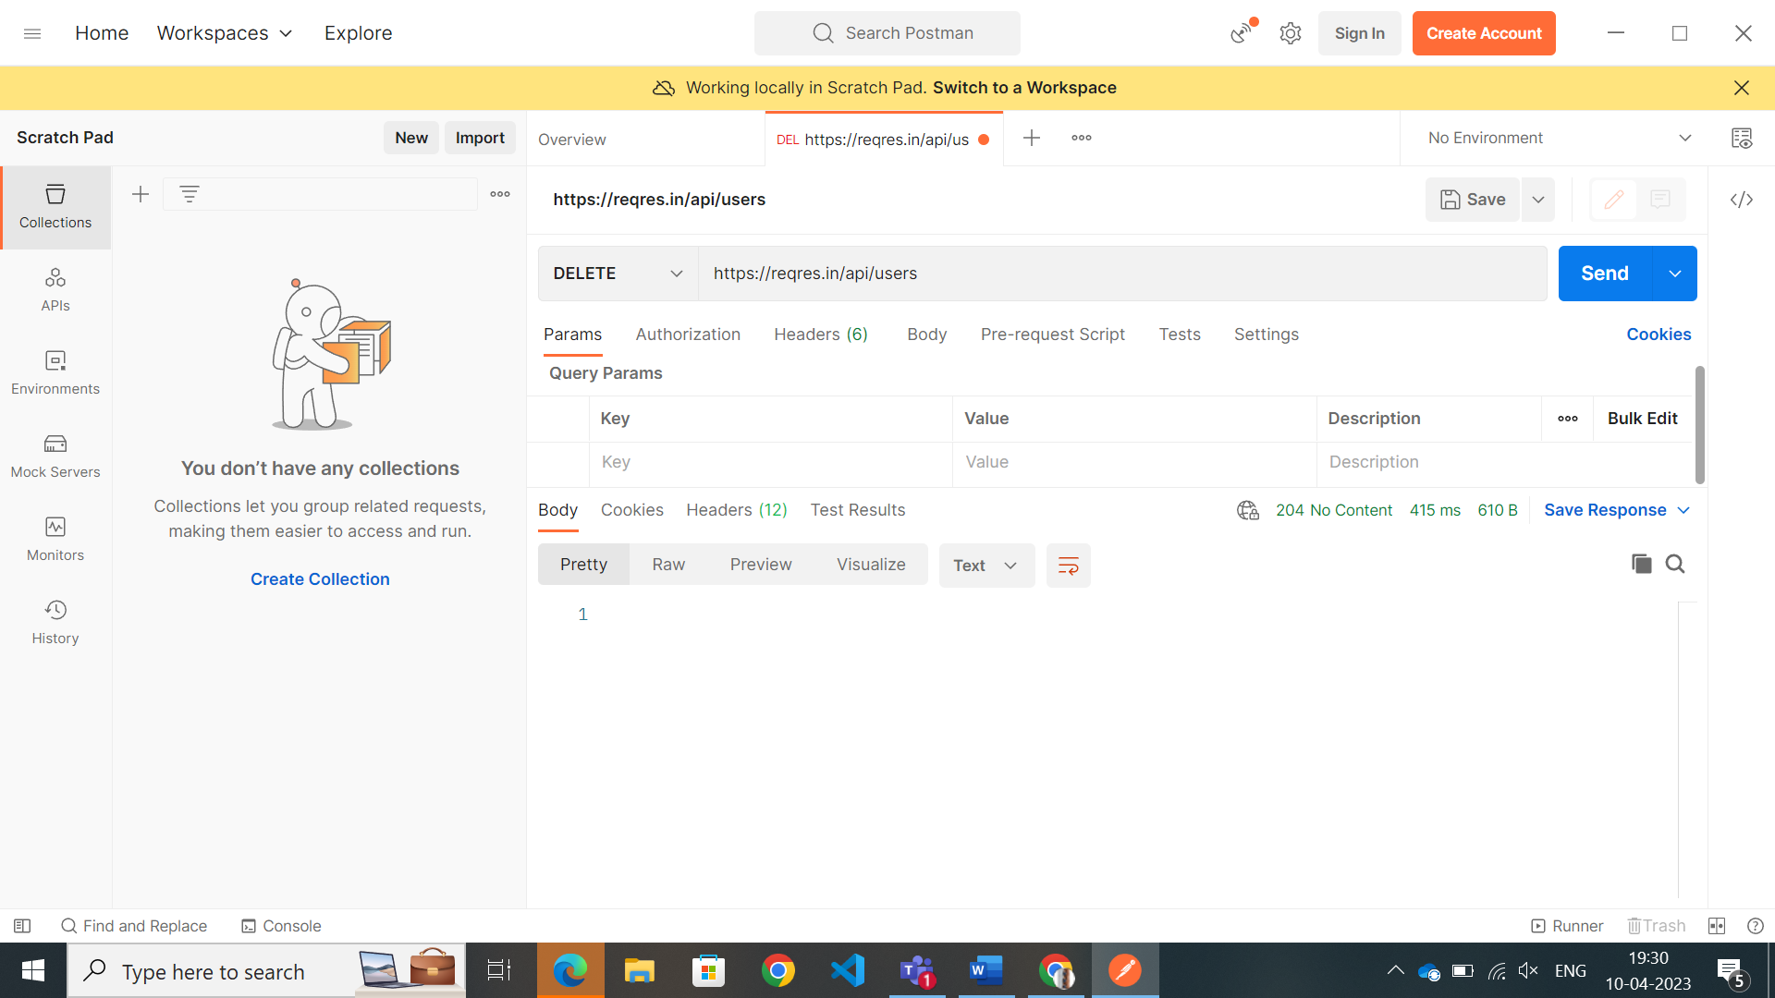

**Put:**

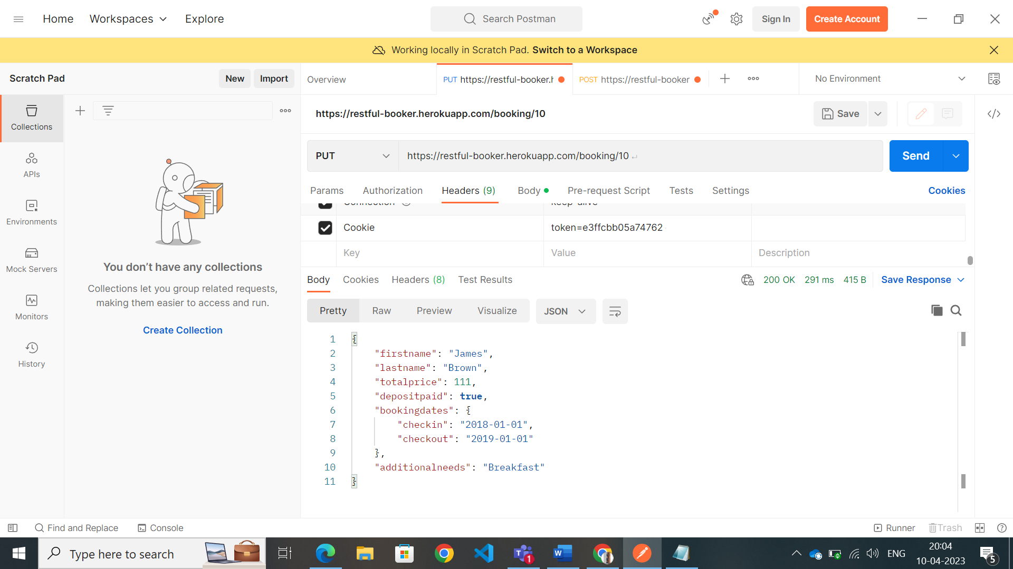

**Patch:**

